

**UNIVERSITY OF PETROLEUM AND ENERGY STUDIES**

**School of Computer** **Science**

**2020-21**

**GRAPHICS AND ANIMATION TOOLS LAB**

**Faculty: Dr. DURGANSH SHARMA**

**Assistant Professor**

**Department of Cybernetics.**

**School of Computer Science, UPES**

**Submitted By:**

**Name- Ishita J Karmakar**

**Roll no-R100217107**

**Batch-B3**

**Semester- 7**

**Course-B. Tech CSE-OSOS**

**SAP ID- 500064067**

**EXPERIMENT NO 5**

**Aim** :- Design of 3D Text using Blender.

**Objective** :- To Design a 3D Text using features of Blender 2.8.

**STEPS TO MAKE DESIGN A 3D TEXT:-**

1. Open Blender workspace delete the existing cube and Click on the add option and add text of your choice in my case I have added my own name

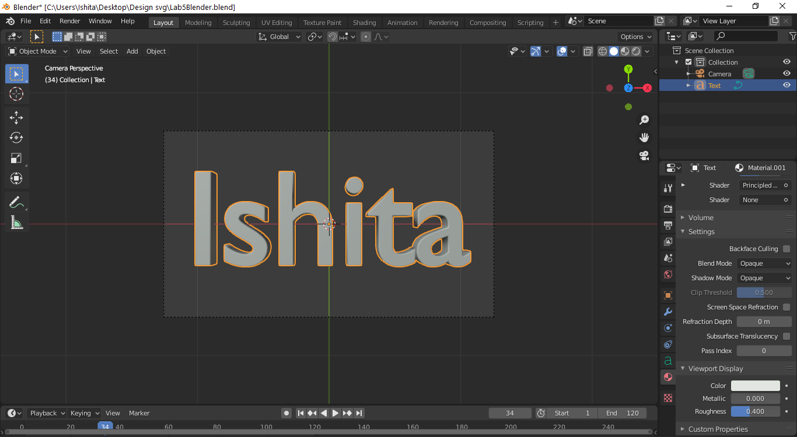

1. Then we will make some adjustments in the text like depth and extrude we will set the depth as 0.02 and extrude as the 0.05
2. After making changes in the text we will add the Bezier circle and adjust the Bezier circle around the text in such a manner that it surrounds the text.
3. Now add a point source of light, make its power 5000W and radius 0.33m.
4. For this point of light, add an object constraint and change the path to Bezier circle.

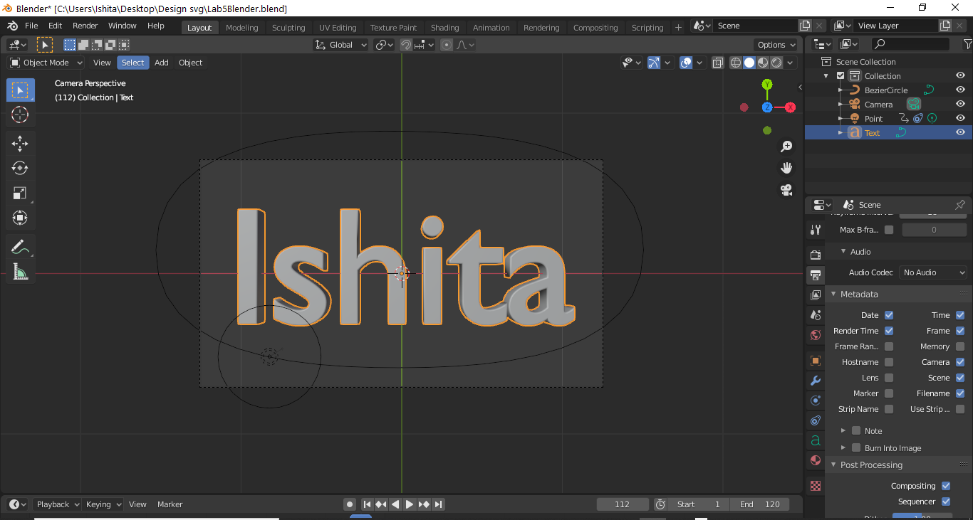

1. After the above step add the random color to the text and add camera point on the boundary of the circle which is surrounded by the text.

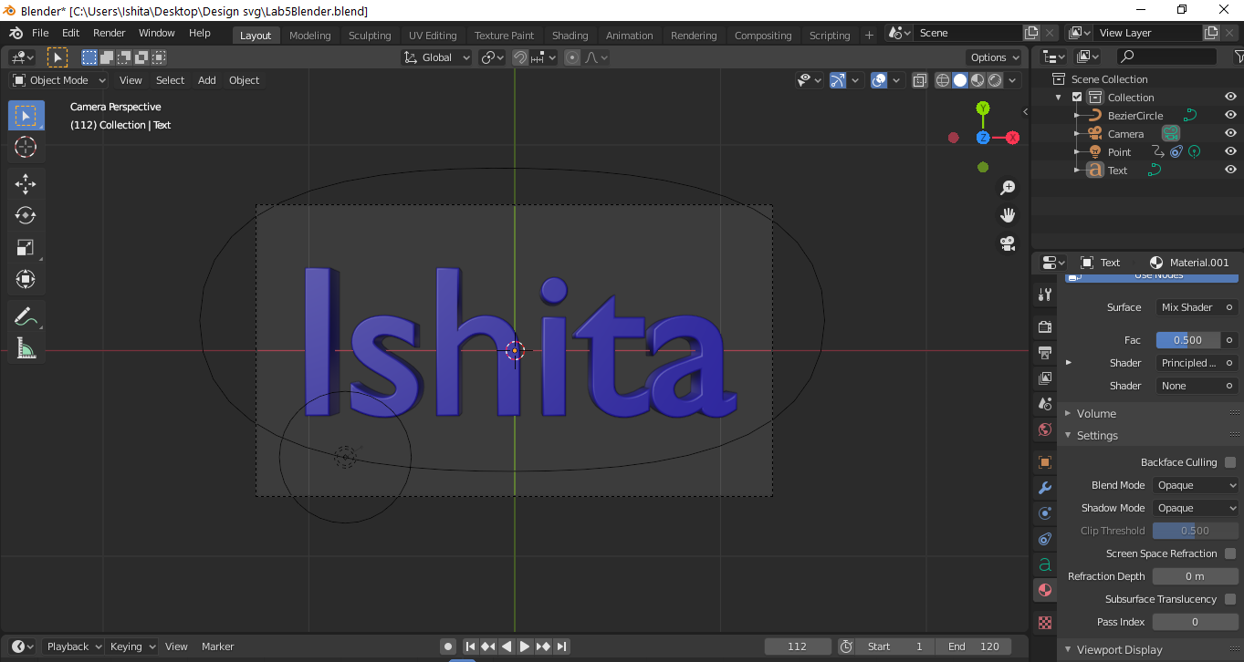

1. Now, we will add the metallic effect to the text and add the shading effect to the text and also, we are going to change the color of the point of light to the color of your choice.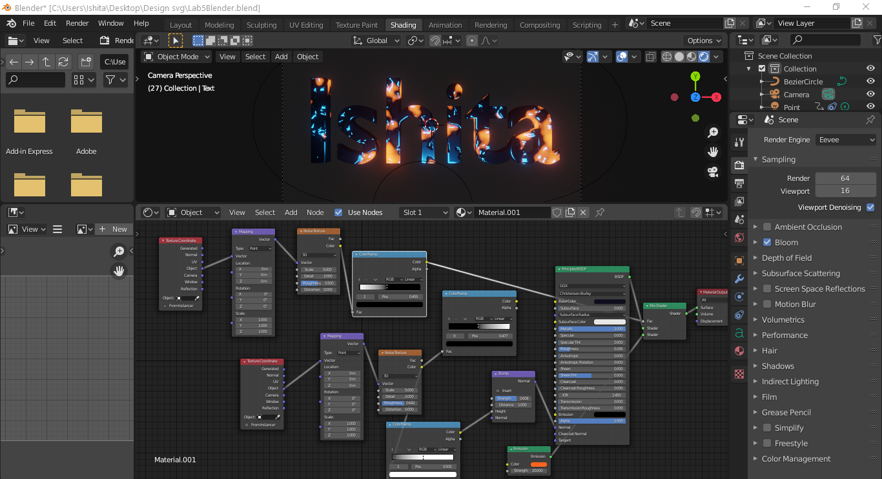
2. After the above step then we will render the animation. 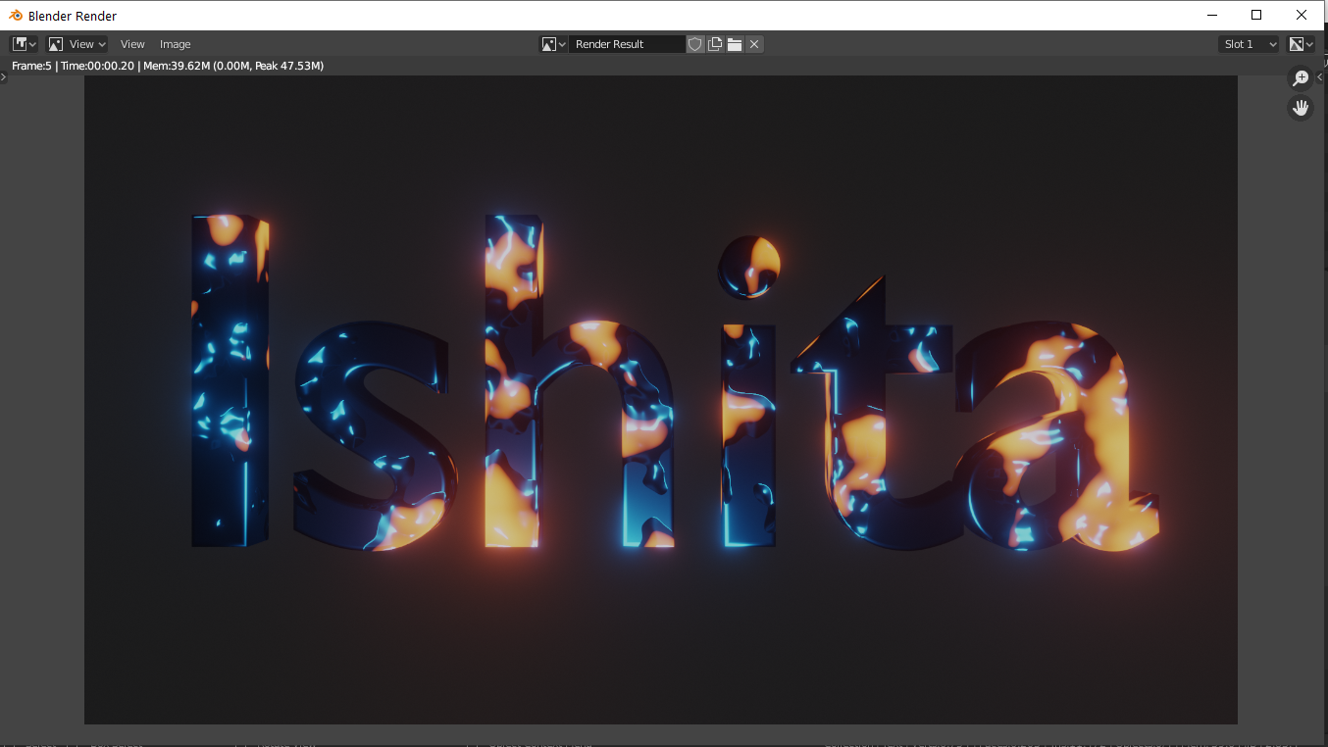

Link for Google Drive: - <https://drive.google.com/drive/folders/1MgNTjgfzRWSX53K821cqtozG8CHYewQw?usp=sharing>